# **Caremark.com Order Status Website**

|  |
| --- |
| **Scenario/Member Statements** |

I requested an order refill yesterday, where can I see that on the website?

My order has not made it to my home, can I see if it shipped?

|  |
| --- |
| **Process Demonstration – Video Walkthrough** |

 Coming Soon.

|  |
| --- |
| **Member to View Their Order** |

1. Hover over the **Prescriptions** tab; click **View Order Status** ORclick the **Order Status dashboard icon**.

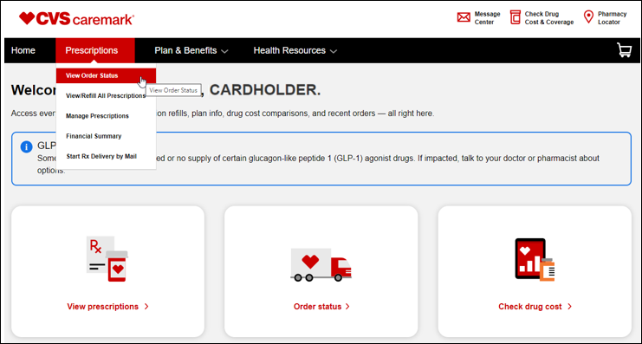

**Result: Recent Orders** page displays this presents the most important details on the page to allow for easier scanning of the orders, click View Details for additional information.

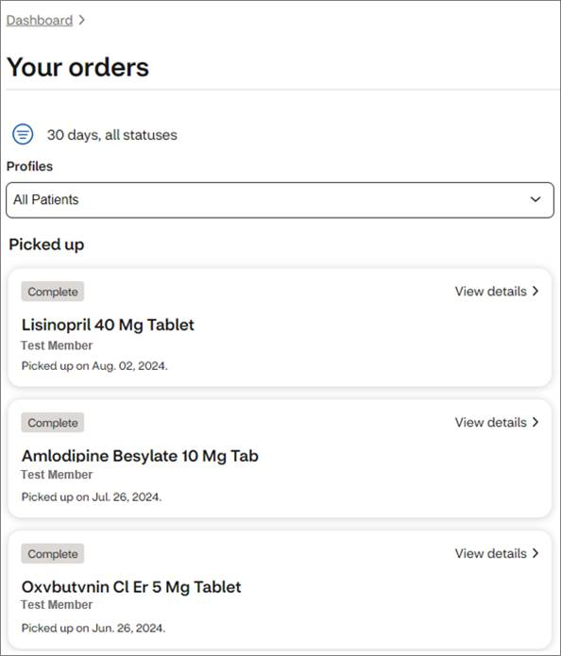

View of details for medication that has **shipped** using Mail Order:

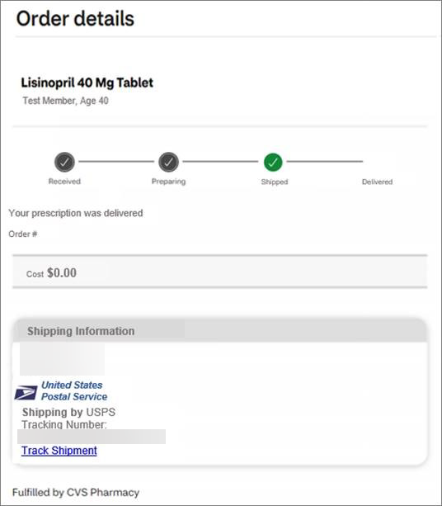

View of details for medication that was picked up at a Retail Pharmacy:

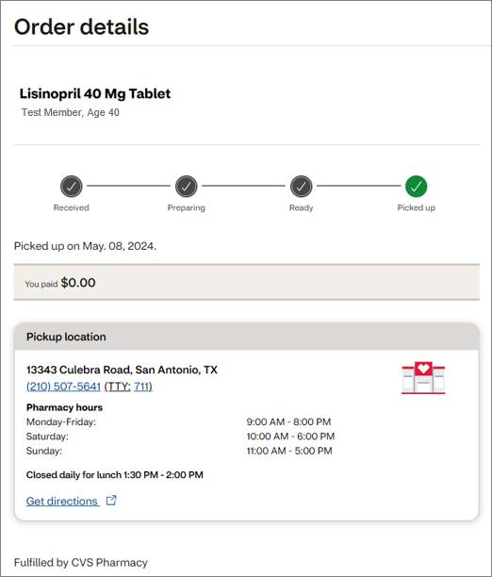

|  |
| --- |
| **Related Documents** |

[Caremark.com - Common Member Assistance Call Types Index](https://thesource.cvshealth.com/nuxeo/thesource/#!/view?docid=947b0b38-401d-4b18-a08e-60348558a9b9)

**Full Details Document:**  [Caremark.com – Order Status/ Integrated Pharmacy Experience (IPE)](https://thesource.cvshealth.com/nuxeo/thesource/#!/view?docid=60a36823-0c27-4d84-953b-e4ecd7d7a569)

Not To Be Reproduced Or Disclosed to Others Without Prior Written Approval

**ELECTRONIC DATA = OFFICIAL VERSION / PAPER COPY = INFORMATIONAL ONLY**